T +44 (0)28 3839 5717 • E chemokines@almacgroup.com • W www.almacgroup.com

Histone H3K9me2, synthetic | 25 µg
Catalogue number: Catalog number: AH3-1002

Almac Peptide and Protein
Technologies

Chemokines

Custom Peptides

Site-Specific protein labelling

Modified Histones

Ubiquitylated peptides

Background
Histones are globular proteins that are subject to a wide variety of post-translational modifications 1, 2. These histone modifications, which occur predominantly on the unstructured N-terminal tails, form an epigenetic code central in the regulation of regular and disease-specific cellular processes, in particular DNA replication, repair and transcription 3, 4.
Our synthetic modified histones correspond exactly to the sequences of the natural modified Histones, containing no amino acid replacements or residue analogs, and can be used in a variety of applications, such as substrates for specific histone modification enzymes, protein binding assays and the generation of chromatin preparations.

1 Strahl B et al., 2000, Nature 403, 41; 2 Rando O, 2007, Curr Opin Genet Dev 17, 94;
3 Martin C et al., 2005, Nat Rev Mol Cell Biol 6, 838; 4 Biancotto C et al., 2010, Adv Genet 70, 341
Product Information
Sequence: |  | ARTKQTARK(Me₂)S TGGKAPRKQL ATKAARKSAP ATGGVKKPHR YRPGTVALRE IRRYQKSTEL LIRKLPFQRL VREIAQDFKT DLRFQSSAVM ALQEACEAYL VGLFEDTNLC AIHAKRVTIM PKDIQLARRI RGERA
Purity |  | 95% by Coomassie-stained SDS-PAGE under  reducing conditions
Determined Mass: |  | 15 300.4 Da
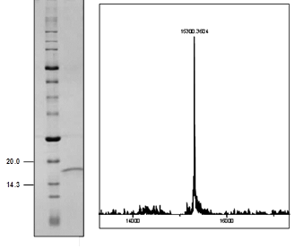 |  |  | Synthetic H3K9me2 analysed by SDS-PAGE (lane 1 MW marker; lane 2 H3K9me2).  Product mass determined by  ESI-TOF mass spectrometry  (expected mass 15 300.9 Da)
Formulation/  Appearance: | White powder, lyophilized.  Protein content determined by Bradford assay.
Preparation and Storage
Reconstitution / Storage: |  | It is recommended that unopened vials are stored at -20 °C to -70 °C for periods of up to 12 months. Avoid repeat freeze-thaw cycles.  Centrifuged vials prior to opening.  Reconstitute in water or a suitable buffer for your assay.

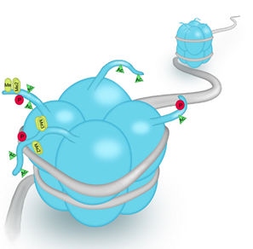

Not fully tested. For research use only. Not for use in human diagnostic or therapeutic procedures.

